

MBoot User Guide

Revision History

Document Version | Date | Author | Comments
V 0.1 | 2009/04/16 | Nick.Lai | Create
V 0.2 | 2009/05/05 | Terry.Tsai | Update
V 0.3 | 2009/07/16 | CM.Chen | Update
V 0.4 | 2010/05/31 | CP.Hsu | Add Chunk Header Format
V 0.5 | 2011/01/14 | CP.Hsu | Add Version Rule of SBoot & UBoot
V 0.6 | 2011/01/19 | Cyber.Chang | Add SPI flash Layout
V 0.7 | 2011/03/26 | Eric.Peng  Cyber.Chang | Add MIU Setting / Environment Variable
V 0.8 | 2011/11/29 | Cyber.Chang | Add Register Address Translation
V0.9 | 2012/02/08 | ERIC.Wu | Update chunk header statu
V1.0 | 2012/10/8 | Eric.Wu | New architecture for u-boot2011.06

Acronyms
Acronym | Description
MBoot | Mstar Bootloader
SBoot | Small Bootloader
UBoot | Universal Bootloader

Content
1. MBoot 1
1.1 Overview of MBoot 1
1.2 MBoot tree 2
1.3 How to build MBoot 3
1.4 How to use MBoot, and burn program through the tftp server 6
1.5 SPI Flash Layout 7
2. SBoot 8
2.1 Overview of SBoot 8
2.2 SBoot setup 9
2.3 SBoot boot flow 11

2.5 Version Rule of SBoot 13
2.6 MIU Setting 15
2.7 Register Address Translation 17
3. Chunk Header Format………………………………………………………
4. UBoot 18
4.1 Overview of u-boot-1.1.6 18
4.2 Overview of u-boot-2011.06 19
4.3 Auto boot sequence 20
4.4 Version Rule of UBoot 20
4.5 Environment Variable 23

5. New architecture for uboot-2011.06
- MBoot
This chapter would provide an introduction of MBoot including overview, code tree, build flow, and setup environment

  - Overview of MBoot
MBoot is the MStar boot loader which is composed of pm.bin, sboot.bin anduboot.bin
MBoot is used to boot up system, so it would initialize H/W setting and then load Linux kernel and applications from NAND flash to DRAM. Exept booting system, MBoot also has charge of software upgrade(oad/net/usb), displaying the booting logo and playing the booting music.
  - MBoot tree
MBoot source code is placed in “//DAILEO/MBoot”.
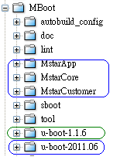
pm.bins are stored in this path.
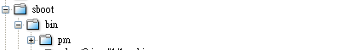
On this source tree, we can see the two u-boot related folders. “u-boot-1.1.6” is for Mstar’s old SOC and “u-boot-2011.06” is for Mstar’s new SOC. Because uboot is an open source code, we wish Mstar’s code can be separated from the open source codes, it can be easy to maintain. So we crated three folders “MstarApp”, “MstarCore” and “MstarCustomer” for u-boot-2011.06. In these three folders, all functions are designed from Mstar’s engineers, and these functions are all based on u-boot-2011.06. “sboot” folder is for sboot.bin. The main task for sboot.bin is low level hardware initialization. pm.bin exists in this source three in binary format. The binary files are all stored in “sboot/bin/pm”.

  - How to build MBoot
The following build flow of MBoot shows how to generate the MBoot bin file.
- Change working directory to MBoot/sboot
- “make menuconfig” to setup SBoot configuration menu
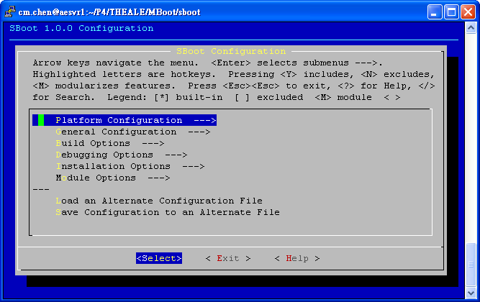

- Select and enter “Platform Configuration”
- Select Chip, Target board, and Memory Map type and then Exit
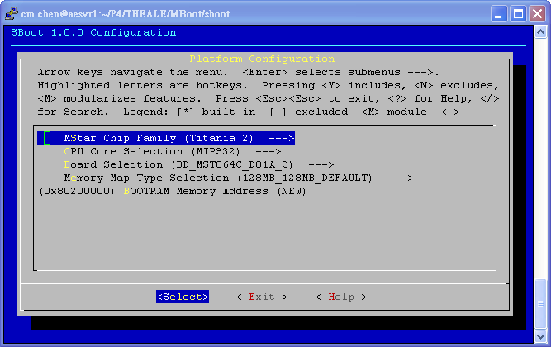
- Select and Enter “Module Options”
- Select which modules are included into UBoot
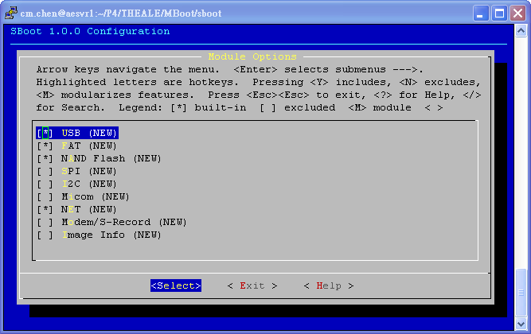

- Select and enter “Save Configuration to an Alternate File”
➔Save configuration file to “.config”
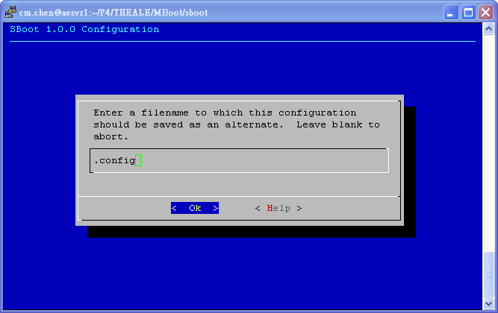

- Exit SBoot configuration menu
- “make” to compile UBoot and SBoot source code and then merge their bin files into MBoot bin file.
- The MBoot bin file would be generated as “MBoot/sboot/out/mboot.bin”
- Use ISP tool to burn-in the MBoot bin file into SPI Flash on the target board
  - How to use MBoot, and burn program through the tftp server
After the target board rebooted, the prompt “<< MStar >>#” would be displayed on console. At this moment, we can type some commands on console to interact with UBoot.
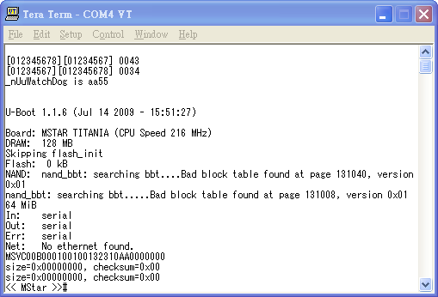

To load Linux kernel and application images through Ethernet interface (especially on developing/debugging stage), TFTP server is needed. The following environment variables should be set for LAN setting
- setenv ipaddr 172.16.89.199 (Based on your local IP address, and plus 1 on third fild.)
- setenv serverip 172.16.88.60 (your local IP address)
- macaddr 00 XX YY 00 00 01 (XXYY is your extension number.)
- saveenv (save environment into NAND Flash)
Type “mstar” command on console to download Linux kernel and applications to DRAM and then write into NAND flash.

  - SPI Flash Layout.

Now there are two booting modes on Mstar’s TV sets, so we have two image layouts for SPI. This two booting modes are “Hosekeeping booting” and “PM51 booting”.

Hosekeeping booting mode:
offset | Code | size
0x00000 | sboot.bin | 0x10000
0x10000 | pm.bin | 0x10000
0x20000 | ChunkHeader | 0x80
0x20400 | u-boot.bin
Last 7th bank | bootlog + boot music | 0x40000
Last 3th bank | signature for nand image | 0x10000
Last 2th bank | signature for nand image | 0x10000
Last 1th bank | ENV1 | 0x10000
Last 0th bank | ENV2 | 0x10000

PM51 booting mode:
offset | Code | size
0x00000 | pm.bin | 0x10000
0x10000 | sboot.bin | 0x10000
0x20000 | Customer Key bank | 0x10000
0x30000 | ChunkHeader | 0x80
0x30400 | u-boot.bin
Last 7th bank | bootlog + boot music | 0x40000
Last 3th bank | signature for nand image | 0x10000
Last 2th bank | signature for nand image | 0x10000
Last 1th bank | ENV1 | 0x10000
Last 0th bank | ENV2 | 0x10000

Actually, PM51 booting mode is only used on secure booting system, So, if you heard “secure booting”, the image layout is the same with “PM51 booting” mode. “Secure booting” is not a topic in this document. If you want to learn more about it, you have study other related documents.

- SBoot
SBoot (Small Bootloader) is a system boot up entry that used to initialize the CPU, Cache, hardware registers, etc. It will jump to UBoot entry after all of settings are done.

  - Overview of SBoot
The directory sboot includes the following subdirectories: bin, inc, scripts, out and src.
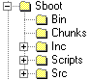

bin：UBoot output bin file and memory map
inc：
1. board definition：Add or modify board definition in MBoot\sboot\inc\xxx\board
2. memory map：Add or modify mmap in MBoot\sboot\inc\xxx\board\mmap
scripts：Script files for menu configuration window
out：MBoot output bin file
src：SBoot source code files which are related with chip drivers
  - SBoot setup

- SBoot environment setup：
Chip ➔ MBoot\sboot\inc\titania2\board\chip
Board ➔ MBoot\sboot\inc\titania2\board
Mmap ➔ MBoot\sboot\inc\titania2\board\mmap

- Boot entry and address in sboot.lds file
  - Entry(BOOT_Entry)
  - Start address: 0xBFC00000
  - boot.o should be put in the first section and its code size can’t be larger than 3Kbytes

MEMORY
{
boot : ORIGIN = 0xBFC00000, LENGTH = 3K
rom : ORIGIN = 0x94000000+0xC00, LENGTH = 8K
ram : ORIGIN = 0x80200000, LENGTH = 128K
sram : ORIGIN = 0x84000000, LENGTH = 1K
}

SECTIONS
{
.text1 :
{
KEEP(*boot.o(.text*))
} > boot
.text2 : AT ( LOADADDR(.text1) + SIZEOF(.text1) )
……
}

- Enable SBoot cache：
bal BOOT_InitCache

- Hardware register setup：
MBoot\sboot\src\xxx\bootrom.c
- Setup CPU clock, UART baud rate：
MBoot\sboot\src\xxx\boot.inc

- Jump to UBoot：
MBoot\sboot\src\xxx\bootram.s
➔ BOOT_CopyBootRAM ➔ BOOTRAM_Entry ➔ UBoot entry
  - SBoot boot flow
SBoot flow chart is depicted as the following. SBoot starts from SPI Flash @0xBFC00000 to initialize H/W setting, execute some C code functions of H/W setting by using the DSPRAM space, copy bootram section from SPI Flash to DRAM to copy UBoot from SPI flash to DRAM, and finally jump to UBoot entry.
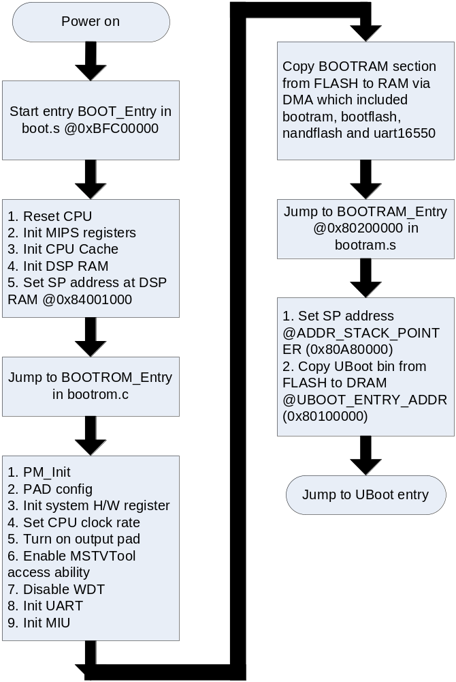

  - Version Rule of SBoot
- How to set SBoot version：
Set the change list number of SBoot into the following place before sboot.bin is built.

//MBoot/sboot/src/version.h
//-------------------------------------------------------------------------------------------------
// Version Control
//-------------------------------------------------------------------------------------------------
#define MSIF_TAG {'M','S','V','C'} // MSVC
#define MSIF_CLASS {'0','0'} // DRV/API (DDI)
#define MSIF_CUS {'0','0','S','3'}
#define MSIF_QUALITY 0
#define MSIF_MOD {'S','B','T','_'}
#define MSIF_DATE {'Y','Y','M','M','D','D'}
#define MSIF_SBT_CHANGELIST {'0','0','2','8','4','7','1','2'} //P4 ChangeList Number

#define SBT_VER /* Character String for SBOOT version */ \
MSIF_TAG, /* 'MSIF' */ \
MSIF_CLASS, /* '00' */ \
MSIF_CUS, /* '00S0' */ \
MSIF_QUALITY, /* 0 */ \
MSIF_MOD, /* 'SBT_' */ \
MSIF_DATE, /* 'TTMMDD' */ \
MSIF_SBT_CHANGELIST, /* CL# */ \
{'0','0','0'}

typedef union _MSIF_Version
{
struct _DDI
{
U8 tag[4];
U8 type[2];
U16 customer;
U16 model;
U16 chip;
U8 cpu;
U8 name[4];
U8 version[2];
U8 build[2];
U8 change[8];
U8 os;
} DDI;
struct _MW
{
U8 tag[4];
U8 type[2];
U16 customer;
U16 mod;
U16 chip;
U8 cpu;
U8 name[4];
U8 version[2];
U8 build[2];
U8 changelist[8];
U8 os;
} MW;
struct _APP
{
U8 tag[4];
U8 type[2];
U8 id[4];
U8 quality;
U8 version[4];
U8 time[6];
U8 changelist[8];
U8 reserve[3];
} APP;
} MSIF_Version;

const MSIF_Version _sbt_version = {
.APP = { SBT_VER }
};

- How to get SBoot version in main application：
Read the last 32bytes in sboot.bin. (sboot.bin would be padded to be 64Kbytes, and SBoot version is kept in the last 32bytes of these 64Kbytes by off-line executable tool: pad_version.)

//MBoot/sboot/Makefile
out/sboot.bin: out/sboot.elf
$(Q)$(OBJCOPY) -O binary -I elf32-little $< $@
$(Q)$(HOSTCC) -o ./scripts/pad_version ./scripts/pad_version.c
$(Q)./scripts/pad_version $@

  - MIU Setting
- MIU init flow
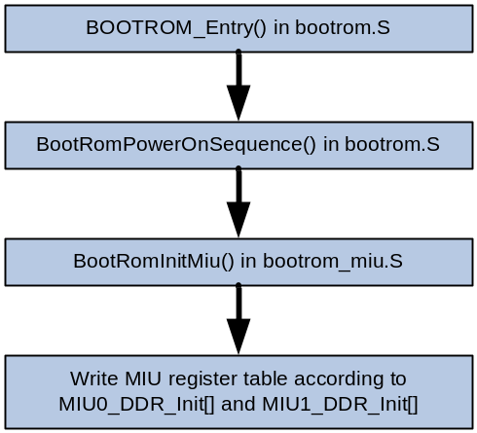
You can configure 3 settings of MIU.
- Memory frequency
MIU0
➔ make menuconfig → Platform Configuration → Memory Frequency Selection
MIU1
➔ Modify MIU1_DRAM_FREQ in the board config. E.g. As in BD_MST008B_10ATX_10405.h
- Memory size
➔ make menuconfig → Platform Configuration → Memory Map Type Selection
NOTE: If meets boot up problem, please consult CAE to check if needed to modify MIU0_DDR_Init[] or MIU1_DDR_Init[].
E.g. _RV32_2( 0x101202, 0x03a3 ) for MIU0, _RV32_2( 0x100602, 0x02a2 ) for MIU1.
- MIU interface
➔ Set MIU_INTERFACE / MIU1_INTERFACE to DDR2_INTERFACE_BGA or DDR3_INTERFACE_BGA in the board config.

- An example to configure the memory setting at board define
ex: //MBoot/sboot/inc/titania13/board/BD_MST008B_10ATX_10405.h
You should adjust the MIU type (DDR3 or DDR2) and MIU frequency as following:
//------Memory Setting----------------------------------------------------------
#define BOOTUP_MIU_BIST 1
#ifndef MEMORY_MAP
#define MEMORY_MAP MMAP_128_128MB//MMAP_64MB
#endif
#define MIU_INTERFACE DDR3_INTERFACE_BGA //DDR3_INTERFACE_BGA

#define MIU1_INTERFACE DDR2_INTERFACE_BGA //DDR3_INTERFACE_BGA
#define MIU1_DRAM_FREQ 800 //950 / 1066 / 1300 / 1600

#define ENABLE_AUTO_PHASE
//------Memory Setting----------------------------------------------------------

p.s. MMAP is depended on .config file, not here.

- Find the corresponding MIU header file of board：
ex: //MBoot/sboot/src/titania13/include/MIU_MST008B_10ATX_10405.h

Now you can take the miu setting table retrieve from CAE, and modify the value of register. Ex:
_RV32_2( 0x101204, 0x000A ), //if I64Mode =0x8b else =0x0b
_RV32_2( 0x101206, 0x0434 ), //refresh cycle=0x50
_RV32_2( 0x101208, 0x1899 ), //reg_tRCD
_RV32_2( 0x10120a, 0x2155 ), //reg_tRRD
_RV32_2( 0x10120c, 0x95a8 ), //reg_tWL
_RV32_2( 0x10120e, 0x406b ), //tRFC
_RV32_2( 0x101210, 0x1a50 ), //MR0

  - Register Address Translation
- MIPS
[RIU offset address(16bits) X 2+ bank address] X 2 + 0XBF000000

- ARM
[RIU offset address(16bits) X 2+ bank address] X 2 + ARM RIU start address

- 8051
RIU offset address(16bits) X 2+ bank address

- Chunk Header Format
sboot.bin uses some information that keep in the chunk header for jumping to next application program (Here the next application program means UBoot for Linux platform or means Chakra2 main application for Non-OS platform).

The chunk header format goes as follows.
The chunk header’s base address depends on booting mode. If booting mode is “BOOTING_FROM_OTP_WITH_PM51” or “BOOTING_FROM_EXT_SPI_WITH_PM51”, base address is 0x30000. If booting mode is “BOOTING_FROM_EXT_SPI_WITH_CPU”, base address is 0x20000.
 | 0x00 | 0x04 | 0x08 | 0x0C
0x00 | UBOOT_ROM_START | UBOOT_RAM_START | UBOOT_RAM_END | UBOOT_ROM_END
0x10 | UBOOT_RAM_ENTRY | Reserved1 | Reserved2 | BINARY_ID
0x20 | LOGO_ROM_OFFSET | LOGO_ SIZE | SBOOT_ROM_OFFSET | SBOOT_ SIZE
0x30 | SBOOT_RAM_OFFSET | PM_ROM_OFFSET | PM_SIZE | PM_RAM_OFFSET
€0x40 | SECURITY_INFO _LOADER_ROM_OFFSET | SECURITY_INFO _LOADER_SIZE | SECURITY_INFO _LOADER_RAM_OFFSET | CUSTOMER_KEY_BANK_ROM_OFFSET
0x50 | CUSTOMER_KEY_BANK_SIZE | CUSTOMER_KEY_BANK_RAM_OFFSET | SECURITY_INFO _AP_ROM_OFFSET | SECURITY_INFO _AP_SIZE
0x60 | UBOOT_ENVIRONMENT_ROM_OFFSET | UBOOT_ENVIRONMENT_SIZE | DDR_BACKUP_TABLE_ROM_OFFSET | POWER_SEQUENCE_TABLE_ROM_OFFSET
0x70 | UBOOT_POOL_ROM_OFFSET | UBOOT_POOLSIZE
0x80

- UBoot
UBoot (Universal Boot loader) is a free open source under GPL which is developed by DENX.

4.1 Overview of u-boot-1.1.6
MStar UBoot is based on u-boot version 1.1.6 that used a simple command line interface (CLI) to interact with user, usually over a serial console port.
UBoot applies some features such as,
- Accept commands on console to setup environments and execute the system operation
- Initialize the system
- Load the kernel and application to DRAM through Ethernet interface
- Write the kernel and application into NAND Flash
- Set the kernel arguments
- Uncompress the kernel
- Pass the boot arguments to kernel to startup
The u-boot-1.1.6 directory includes the following subdirectories: board, common, cpu, disk, doc, drivers, fs, include, lib_generic, lib_mips, net, post, rtc, and tools.
Directory | Description
Board | board define
common | Command and environment setup
Cpu | MIPS cpu start.s
Disk | Reports device info to the user
Doc | Documents
drivers | NAND driver, emac driver, usb driver…
Fs | ext2, fat, fdos, jffs2, …
include | header file
lib_generic | generic lib
lib_mips | MIPS lib
net | net, tftp, …
post | Power on self test
rtc | Real time clock

4.1.2 UBoot Image
- Image layout:
- Entry is _start @0x875F0180 in vectors.S
- .u_boot_cmd: all the commands procedures are put in this section

4.1.3 UBoot startup
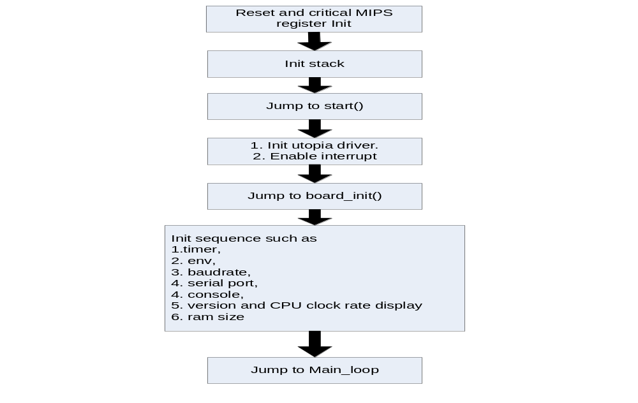

4.1.4 UBoot main flow
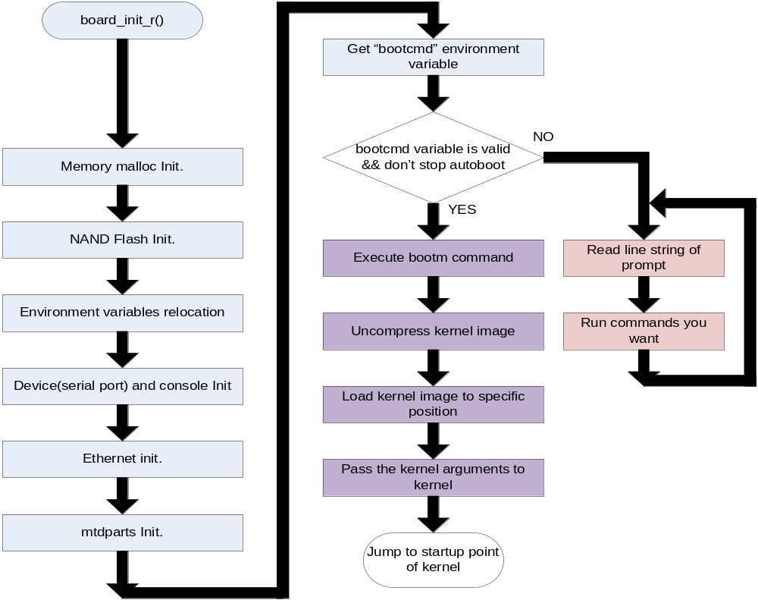4.2 Overview of u-boot-2011.06

4.3 Auto boot sequence

Run command with “bootcmd”
  - bootcmd=nand read.e 81000000 KL 300000; bootm 81000000;
1. Read kernel image from NAND Flash
2. Call the function - do_bootm()
➔ Load image header from 0x81000000
➔ Get Image real data address (entry - header offset)
➔ Decompress image to the data load adder space (hdr->ih_load)
➔ Read MStar bin from NAND Flash via command “cpmsbin”
3. Call the function - do_bootm_linux()
➔ Get the kernel entry point (hdr->ih_ep)
➔ Initialize linux parameters:
“Bootargs” are Linux kernel required parameters.
These parameters are put in “Boot parameters section”.
➔ Initialize environment set:
Memory size, initrd address and size, flash address and size
➔ Jump to kernel entry point to start Linux kernel code

4.4 Version Rule of UBoot
- How to set UBoot version：
Set the change list number of UBoot into the following place before mboot.bin is built.

//MBoot/u-boot-1.1.6/include/ms_ver.h
static char MBOOT_VBuf[32] = {'M', 'S', 'V', 'C', '0', '0',
'B', '0',
BuildNum0,
BuildNum1,
BuildNum2,
BuildNum3,
BuildNum4,
BuildNum5,
'0', '0', '2', '0', '8', '7', '6', '8',
'T', 'H', '0', '0', '0', '0', '0', '0', '0',
'T'};

- How to get UBoot version in main application：
Call prom_getenv("MBoot_version") to get UBoot version which is kept in environment variables.

//MBoot/u-boot-1.1.6/lib/lib_mips/mips_linux.c
/*send MBoot version to linux kernel by seting environment*/
/*please use prom_getenv("nev_name") function to get this information (e.g. prom_getenv("MBoot_version");)*/
/*prom_getenv() define in \\RedLion\2.6.28.9\arch\mips\mips-boards\generic\init.c */
memcpy(MBoot_Ver,MBOOT_VBuf,32);
MBoot_Ver[32]='\0';
linux_env_set ("MBoot_version", MBoot_Ver);

4.5 Environment Variable
You can use UBoot environment variable to store program settings. They would be stored in a non-volatile memory, SPI flash or NAND flash. You can configure it by: make menuconfig → Module Options → Env Config.
- UBoot commands to manage environment variable
- printenv
➔ Print values of all environment variables
- setenv
➔ Set environment variable 'name' to 'value ...'
- saveenv
➔ Update environment variables to the non-volatile memory.
- Environment variable – bootcmd
Defines the command to be executed in the end of UBoot stage. Mostly it is a command to bring up Linux kernel.
- Environment variable – bootargs
Defines the boot parameters passed to Linux kernel. Kernel would change its behaviors according to them. E.g. Modify console could enable/disable printing messages after kernel boot up.
- Enable printing message
setenv bootargs console= ttyS0,115200 ubi.mtd=3,2048 root=ubi:RFS rootfstype=ubifs ro LX_MEM=0x2000000 EMAC_MEM=0x100000 DRAM_LEN=0x10000000 LX_MEM2=0x66381000,0x1C00000 BB_ADDR=0x7FFF000 mtdparts=edb64M-nand:256k(NPT),256k(KL_BP),5m(KL),121m(UBI),-(NA)
- Disable printing message
setenv bootargs console=/dev/null ubi.mtd=3,2048 root=ubi:RFS rootfstype=ubifs ro LX_MEM=0x2000000 EMAC_MEM=0x100000 DRAM_LEN=0x10000000 LX_MEM2=0x66381000,0x1C00000 BB_ADDR=0x7FFF000 mtdparts=edb64M-nand:256k(NPT),256k(KL_BP),5m(KL),121m(UBI),-(NA)
- Environment variable – bootdelay
Defines the time (second) to wait before execute bootcmd.
E.g. setenv bootdelay 0
E.g. setenv bootdelay 3
- Environment variable – UARTOnOff
Defines if uart on or off. (Default on)
E.g. setenv UARTOnOff on
E.g. setenv UARTOnOff off
- New architecture for u-boot-2011.06

  - Description for three folders
In order to maintain easily, we created three folders for Mstar’s and Customer’s functions.
“MstarCore” is for driver, “MstarApp is for application, ex: software upgrade, osd, display booting logo, and booting music..etc. “MstarCustomer” is for customization. All functions in these three folders are based on u-boot-2011.06.

  - Entry point.
There are three entry points for adding our functions into uboot’s booting flow.
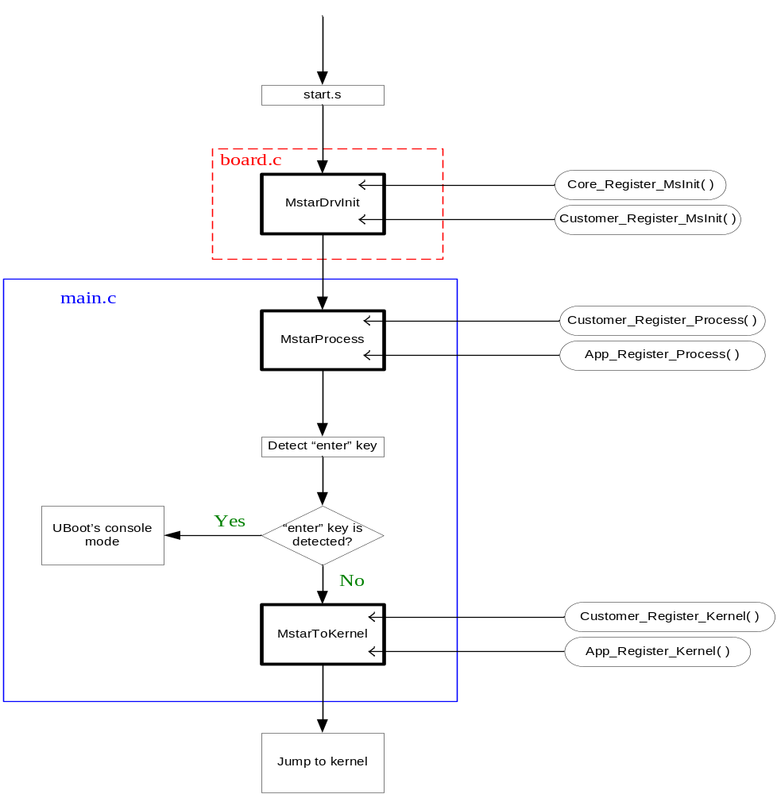All of mstar’s or customer’s function are added from these three points. “Core_xxx” means that it’s for driver owner. “App_xxx” means that it’s for application owner. “Customer_xxx” means that it’s for customization.

    - Register command to cmdTable
We have entry points for different phase now, and we wish every developer can follow the Mstar’s rules in this entry points. We don’t use function call in these entry points, we only register command in it. For example:
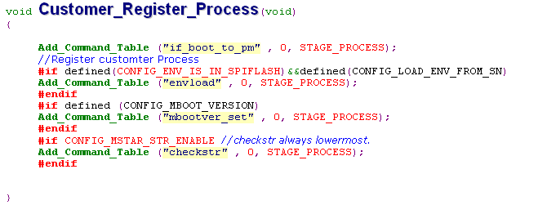
We package the customization functions into different commands, and then register these commands through function “Add_CommandTable”. If we follow this rule, we can get some advantages.
  - We can test customization behaviors throng commands on uboot’s console mode.
  - We can use command “showtb” to double check which commands are registered. It’s very good when we get a failed set.

  - Services
Now, we have already prepaed some command and functions for customization, like usb upgrade, oad upgrade, network upgrade..etc. We can use these basic services to help our customer developing their specific.

  - How to pacage a new command
It is very easy to add a new command on uboot’s environment. We can refer to MsUtility.c and cmd_MsUtility.c, we can get many examples from this file.

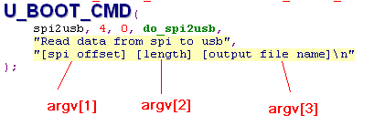

  - How to add a new file in these three folders.
- Cerate a source file in specific folder.
For example, If we want to add a new file in MstarCustomer, we have to create a new c file in /MstarCustomer/src
- Edit /MstarCustomer/makefile
Add our new file to COBJS
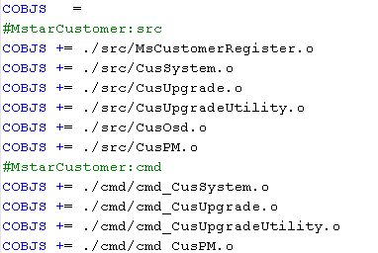
- If we have head file, place the haed file in /MstarCustomer/Include

